SEPA Payment Gateway for WooCommerce

Seamlessly adds SEPA Direct Debit support to WooCommerce. Easily collect IBAN and BIC of your customers during checkout and export SEPA-XML-files ready for upload to your bank.

* Dynamic real-time validation of IBAN and BIC (s. video for demonstration).
* Creates XML-files that are 100% compliant to PAIN.008.003.02 and new PAIN.008.001.02 (SEPA 3.x) standard.
* Automatic Umlaute-transformation.
* Basic fraud prevention: highlights mismatching shipping name and account holder.
* Multiple payments in one XML-file.
* See all open payments in an overview before exporting XML. Easily navigate to orders to check details.
* Supports WooCommerce Subscriptions.

# Licenses

Contains the php-sepa-xml library, licensed under the LGPL: <https://github.com/php-sepa-xml/php-sepa-xml>  
Contains the jQuery Validation library, licensed under the MIT license: <https://github.com/jzaefferer/jquery-validation/>

# Versions

1.12 Updated Sepa-XML creation library to latest version. Now also supports non-german special characters.

1.11 Added option to include payment information (IBAN, BIC, account holder) in emails sent to shop admin  
Added option to automatically mark order as payed (order status becomes “Processing” instead of “On Hold”).

1.10 Added support for storing payment method in user account so that sepa information does not have to be entered again for subsequent order.

1.9 Added support for exporting multiple payments in a single “Payment Information” segment within the XML-file. This is required by some banks (e.g., German Commerzbank) and can reduce costs with other banks.

1.8 Added support for new SEPA version 3.x by optionally generating pain.008.001.02 files.

1.7 Added support for manually changing the payment method and editing the SEPA information in the admin backend

1.6.9 Added french translation provided by Nicolas Grandgirard (thanks Nicolas! =)

1.6.8 Fixed error “Fatal error: Allowed memory size …” when trying to export XML files with Subscriptions installed.  
Fixed error “Notice: Undefined index remittance_info…“

1.6.7 Using WooCommerce order number instead of post id for remittance information.

1.6.6 Compatibility to WooCommerce 3.0. Added setting for remittance information.

1.6.5 Fixed issue with old orders that were still created with WooCommerce Subscriptions 1.x.

1.6.4 Fixed issue where direct debit information was empty in subscriptions created with WooCommerce Subscriptions 1.x.

1.6.3 Fixed issue with validating some BIC-numbers.

1.6.2 Support for change of payment method by customer added.

1.6.1 Does not export payments for cancelled orders anymore.

1.6 Updated to fully support WooCommerce Subscriptions 2.0 including multiple Subscriptions. **Please note:** The plugin is now no longer compatible with Subscriptions 1.x!  
Set due date for payment one day into the future to prevent banking software from rejecting XML-file.

1.5.4 Made exporting payments as COR1 express debits optional. Default is the basic or CORE debit which has a five working day delay before the payment is fulfilled. Please check with your bank before activating COR1 debits.

1.5.3 Convert IBAN, BIC and Creditor ID to uppercase. Some banks seem to reject the XML if it contains lower case letters in these fields.

1.5.2 Not released.

1.5.1 Removed dependency on php BC Math library, which is missing on some hosted webspaces.  
 Remove white space from IBAN and BIC before storing them in the database.

1.5 Added SEPA information to the edit order page.

1.4.1 Fixed missing description on checkout-page.

1.4 Fixed issue when WooCommerce Subscriptions is not installed.

1.3 Fixed incompatibility with WooCommerce Stripe gateway.

1.2 Added hint when trying to export payments without setting up the target account information.  
Setting SEPA sequence correctly to ONE_OFF, FIRST or RECURRING depending on payment type.

1.1 Added support for WooCommerce Subscriptions  
1.0 Initial release

# What is SEPA Direct Debit?

SEPA Direct Debit is a way to directly withdraw money from your customers account. This is convenient for your customers, because they only need to provide their account details during checkout and everything else is automatic for them. It is also a very cheap payment method for you as a shop owner because there is no third party, like a payment service involved and bank fees for SEPA direct debit are typically very low.

In order to collect SEPA direct debit withdrawals, you need a so called **Creditor ID**. In Germany, this ID is assigned by the Bundesbank (🡪https://extranet.bundesbank.de/scp/).

# How does it work?



SEPA Payment Gateway for WooCommerce provides an easy way to offer SEPA Direct Debit payment to your customers in 4 simple steps:

1. Every time, one of your customers chooses SEPA Direct Debit as the payment method in an order, SEPA Payment Gateway creates a **new outstanding payment**.
2. You can now **login to the Wordpress Admin backend** and **export all outstanding payments into a single SEPA XML file**. How often you do this is completely up to you – once a day, multiple times per day, once a week – whatever rhythm suits your business best.
3. **Download the SEPA-XML file created and upload it to the online banking of your bank.** You will need a business account for this to work and some bank require you to unlock SEPA direct debit payments before this is possible. Contact your bank to find out more.
4. **Check in your online-banking that the payment has arrived**, then manually set the corresponding order to “Processing” in the WooCommerce backend.

# WooCommerce Integration

SEPA Payment Gateway for WooCommerce integrates with WooCommerce and WooCommerce Subscriptions in the following ways:

1. Adds a new payment gateway that can be configured in the **WooCommerce Settings** in the admin backend (s. Installation-section below).
2. Adds a new payment method for customers to choose during **checkout** (s. Checkout-section below).
3. Adds a new **“outstanding payment” for each order** where SEPA direct debit was chosen as the payment method.
4. Adds a new **“outstanding payment” for each manual renewal or automatic renewal order** processed by WooCommerce Subscriptions.
5. Adds a new page in the WooCommerce admin backend **to export “outstanding payments” to SEPA XML files and download those files.**

## Order Status/ Payment processing

The way in which order status are set differs for initial orders and renewal orders for subscriptions.

### Initial orders of subscription and non-subscription products

For the initial checkout or an order that contains any number of subscription and non-subscription items, SEPA Payment Gateway for WooCommerce **reduces the item stock** (if stock management is configured) and **sets the order to “On hold”** awaiting the SEPA direct debit payment to be completed first.

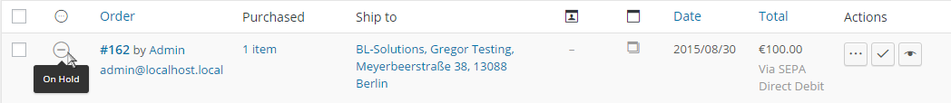

This is also shown in the order comments:

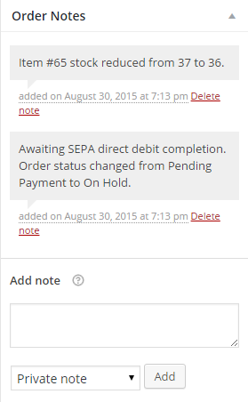

The order needs to be advanced **to status “Processing” manually** after you downloaded the corresponding payment inside a SEPA XML file (s. Export of SEPA XML-files below), uploaded the file to your bank and the bank has received the payment from your customer. This can be done by clicking the button marked with three dots in the order row:



In case, subscription items are contained in the order, **this also automatically sets the subscription to “active”**.

### WooCommerce Subscription renewal orders

For manual and automatic renewal orders created by WooCommerce Subscriptions, when a subscription is renewed, SEPA Payment Gateway for WooCommerce automatically marks the order as payed, setting the status to “Processing” immediately:

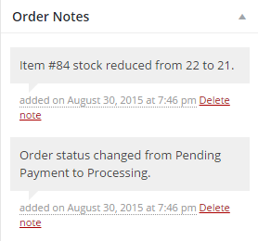

This behavior was chosen because setting the renewal order “On Hold” would result in the corresponding subscription to be put “On Hold” as well. Following the workflow outlined above, where the order is set to “Processing” or “Complete” after the payment has arrived, the subscription would be “On Hold” for a few days typically. While this is not a problem for physical subscriptions, it would interrupt access to digital products or memberships and would thereby annoy customers.

# Installation

1. Copy all content in the folder ‘sepa-direct-debit’ into your wp-content/plugins folder in your wordpress installation.
2. Activate the plugin in the wordpress admin backend (Menu “Plugins”):  
   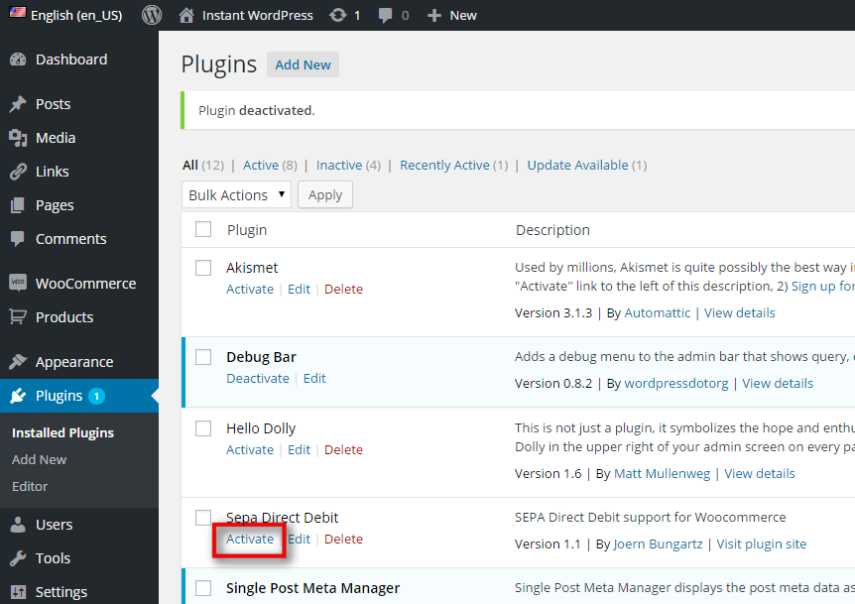
3. Navigate to the “WooCommerce/Settings” menu and select the “Checkout” Tab. Finally, click on the “SEPA Direct Debit” link at the top.
4. Enable the SEPA Direct Debit payment gateway by checking the “Enable SEPA Direct Debit” checkbox.
5. Fill in the information of the target bank account to which SEPA direct debit payments shall be transferred:  
   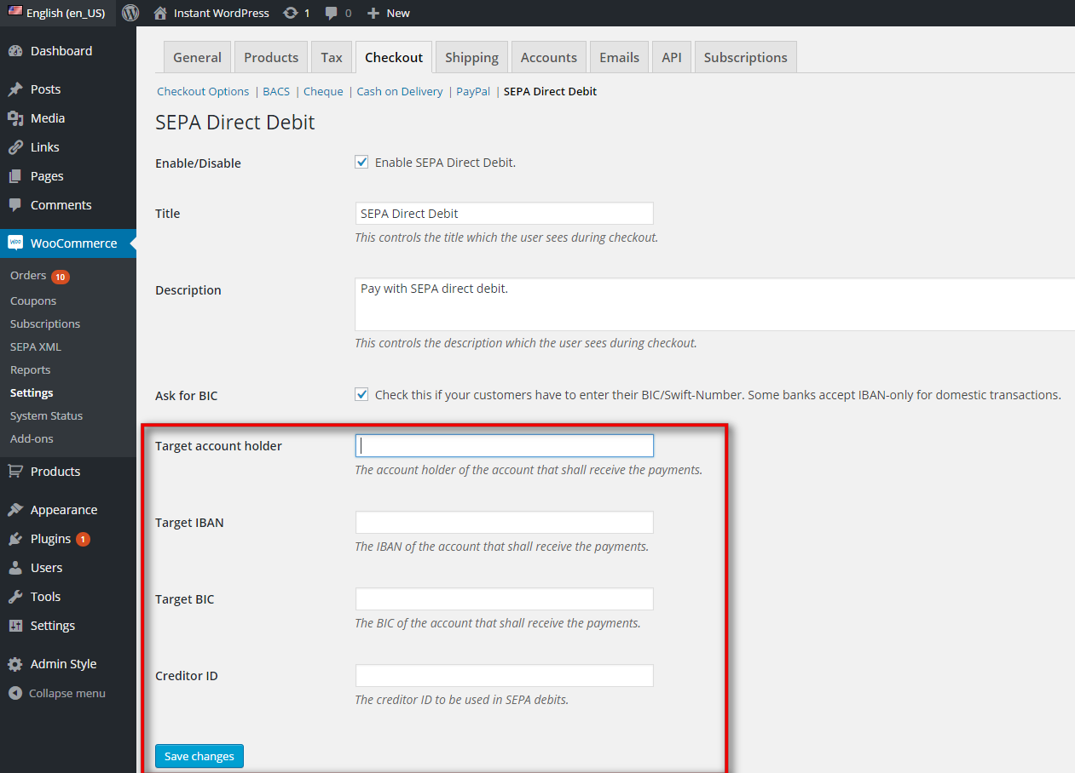
6. You can choose to not ask your customers for the BIC in case your bank accepts domestic SEPA debits without BIC. In this case, deselect the “Ask for BIC” checkbox.
7. Don’t forget to save your changes by clicking “Save changes”.

# Checkout

Now, during checkout, your customers can select SEPA Direct Debit as the payment method. If they do, they need to provide the name of the account holder, the IBAN and BIC (if “Ask for BIC” is selected in the settings, s. “Installation”).

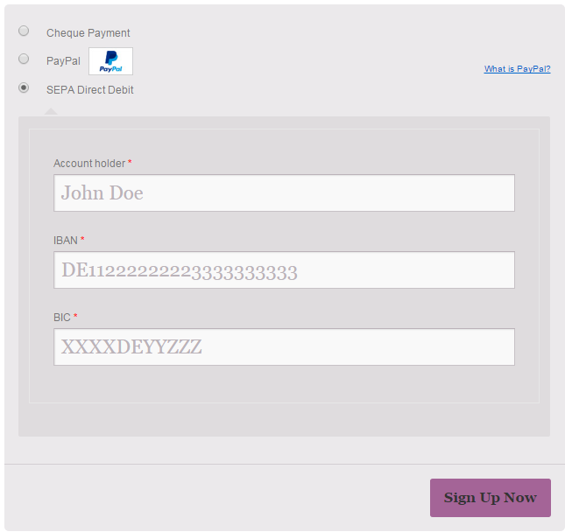

In case an invalid IBAN and/ or BIC is entered, the field is highlighted and an error message shown:

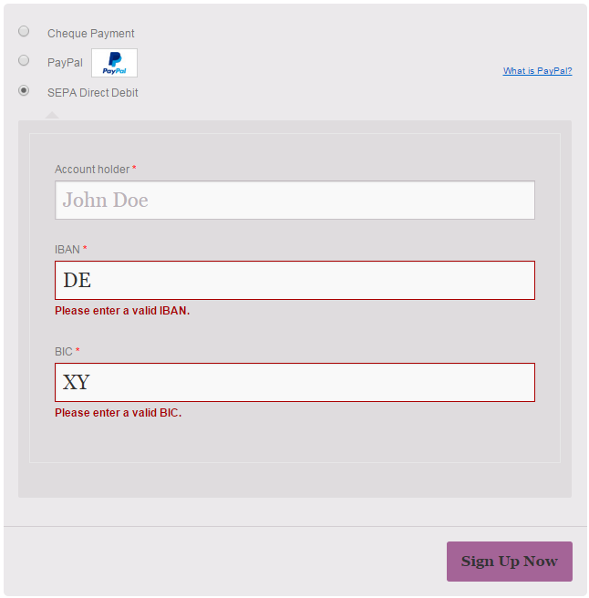

In case the checkout form is submitted regardless, error messages will be shown alongside other WooCommerce messages:

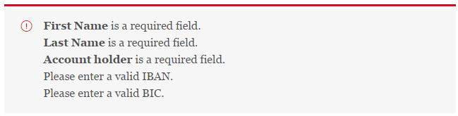

# Export of SEPA XML-files

## List outstanding payments

After the checkout is complete, the payment will show up in the “WooCommerce/ SEPA XML”-menu in the admin backend. Click on the Order number in the first column to navigate to the WooCommerce order view.

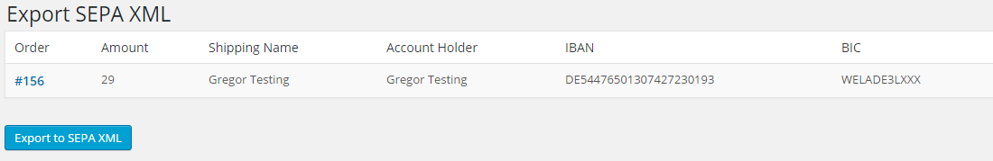

## Basic fraud prevention

In case the name in the shipping address and the account holder do not match, the corresponding payment will be highlighted:

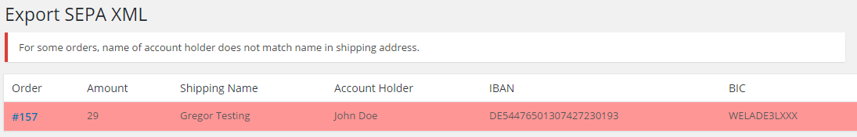

## Export all outstanding payments

To export all outstanding payments into a new SEPA XML-file, click the “Export to SEPA XML” button.

This will create a new SEPA XML-file. All SEPA XML-files previously created are listed below the list of outstanding payments:

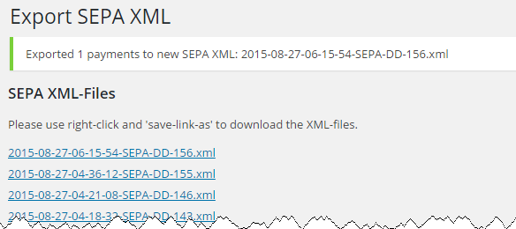

To download the XML-files, make sure to click them with the right mouse button and select “Save link as…”:

